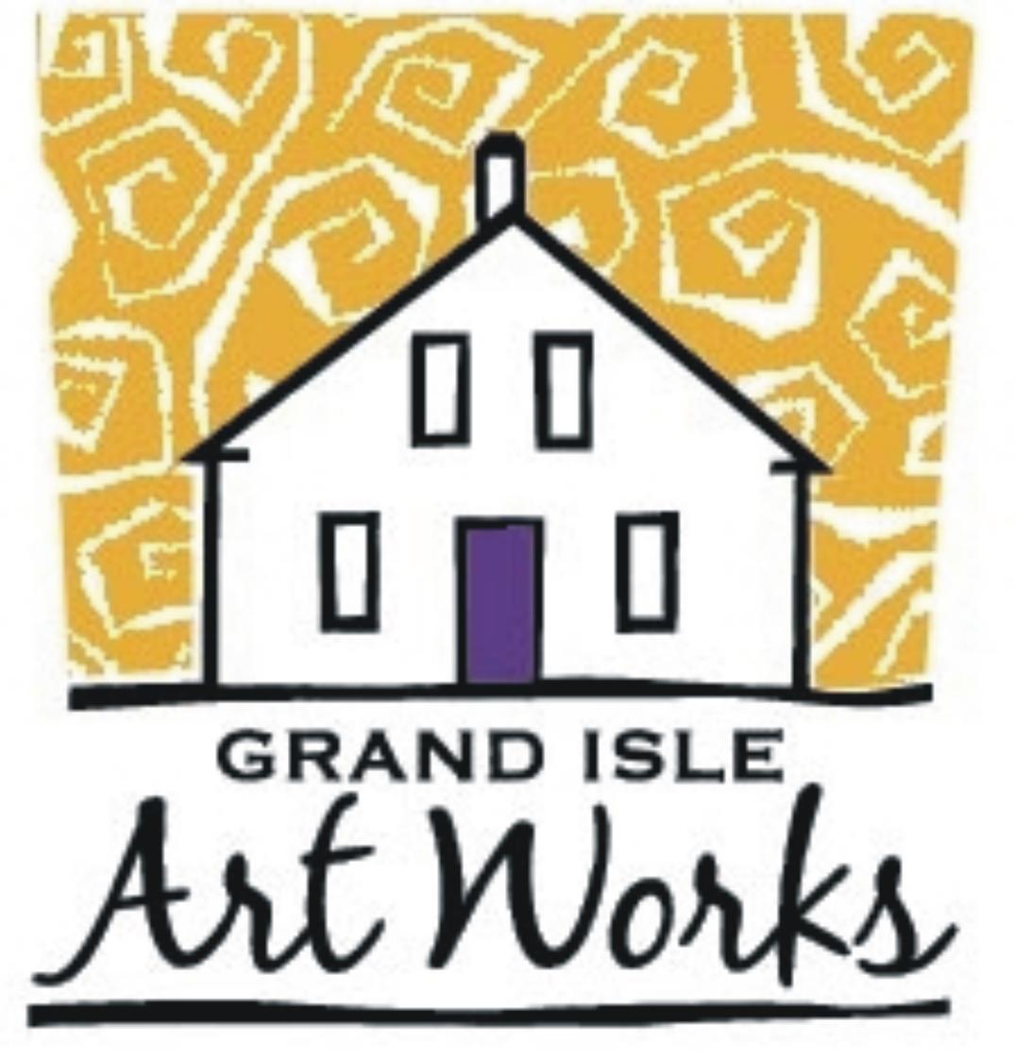
Grand Isle Art Works
A Vermont Artisan Gallery

HOURS of OPERATION

4-6 days per week, season dependent
weekdays plus Saturday: 10-4:00
Sunday: 9 – 3:00

Gallery Expectations:
- Artisans accepted into Grand Isle Art Works need to pay the full year exhibitor's fee before product is hung in the gallery. It is expected that there will be art work in the gallery for one full year.
- Artisans should provide biographical information, and product descriptions to be posted in the gallery, as well as rack cards and/or business cards.
- Artisans will help market Grand Isle Art Works through personal websites, social networking, and personal contacts.
- Artisans need to bring new Works to the gallery for display on a regular basis. If Work is significantly different, it will need to be juried. Artisans may rotate their Work as often as they like, as long as Work is kept in the gallery at all times. Artisans will receive monthly inventory sheets when sales are made.
- Artisans are guaranteed display of Work that is representative of the jury process through the end of the contracted Term. At the end of each Term, Grand Isle Art Works will review all Work for quality and marketability. At that time, Grand Isle Art Works reserves the right to release the Artisan from the renewal of their contract for any reason.
- Grand Isle Art Works will do everything possible to ensure the safety of all Work. The gallery recommends that the artisan carry business insurance. The artist may not hold the gallery responsible in the event of fire, loss, damage, theft, negligent volunteers, or breakage.
- Grand Isle Art Works will work to establish an on-line sales program. Grand Isle Art Works will select 2-4 items to be added to the on-line sales feature on the Grand Isle Art Works web page from the inventory of participating artisans. This Work will be advertised heavily through multiple digital sources especially during the off season winter months. The Artisan Consignment Agreement will apply to these sales. The on-line sales feature will be kept up to date by Grand Isle Art Works.
- Additionally, each Artisan is asked to do one of the following:
  - Offer a craft class. The instructor retains 70% of the class fee.
  - Offer a talk or demonstration about his or her craft.
  - Volunteering as a guest or featured artist in the gallery.
  - Donate 1-2 items to be placed in semi-annual auctions / raffles
  - Helping with special events

Please complete the following and return with your Exhibitor's Agreement.

Grand Isle Art Works
A Vermont Artisan Gallery

Artisan Name:
Business name (if applicable):
Address:
Phone: Email:

Please read and consider the following options available to you as an Artisan exhibitor in the Grand Isle Art Works. Our combined efforts will make this gallery location a vibrant destination for our arts-minded community members and visitors. Please select at least one option from the list below.

I will offer:

____ a craft class
Class Title/topic:
Description of class:
Days and times:

____ a talk/demonstration
Title/topic:
Description of class:
Days and times:

____ items for a silent auction/raffle
Item description:
Value:

Grand Isle Art Works is developing a strong on-line sales platform that highlights our art work for a broader audience.

_____ I will participate in the on-lines sales offered through the GIAW website.

Throughout the year, the gallery will hold special events to feature artists and their work. These will benefit from having GIAW artisans in attendance. A calendar of events will be made available. Each exhibitor is asked to consider attending when possible.

____ I will volunteer in the gallery as a featured artist.

Other ideas:

Please return your completed form to:
Grand Isle Art Works
259 US Route 2
Grand Isle, VT 05458

or email information to: info@grandisleartworks.com

